|  |  |  |
| --- | --- | --- |
| **Problem Chosen** B | **2012 MCM/ICM Summary Sheet** | **Team Control Number** LXX10 |

**Camping：Plan to Embrace Nature**

**Summary**

|  |
| --- |
| The Big Long River, a tourist attraction, has a total length of 225 miles，attracting a wide range of visitors to the area. Currently the only way to enjoy the Big Long River is by boat, with existing 4 mph paddle-powered boats and 8 mph motorized boats with a set number of travel days of 6-18 nights. The problem is how to determine the mode of travel and to figure out the maximum capacity of the river.  The difficulty of the problem is that two teams cannot be present at the same campsite at the same time and teams should with minimal contact with each other. To simplify the problem, reasonable assumptions were made. And two different models were built to solve the problem. Model 1: Parallel moving model. We assume that the same type of vessels depart each day and that the vessels sent on the same day run at the same speed and for the same running time. Thus avoiding the situation where two teams are present at the same camp and meet during the drive at the same time. Solving the objective function by means of the constraints, we find that **the maximum number of departures available is 4050 when the ratio of oar- powered rubber rafts to motorized boats is 2:3.**  However, taking into account the needs and choices of visitors, we then developed Model 2：Generalized Model of Maximum Number of Trips. This model is not as limited as the assumptions in Model 1 and is therefore more generalisable and more responsive to the needs of visitors. What we convinced is that over a longer period of time or with more adequate data, we can solve Model 2 and possibly obtain a more optimal solution.  For sensitivity analysis of model 1, we varied separately ship's speed sequence and the size of the ship's speed. Also ensuring that other conditions remain unchanged, calculations are carried out by substituting into the model and the corresponding results are obtained. We found that the final results did not change significantly and that the sensitivity was within a small range. Therefore, we can say that model one is stable.  Model 1, whose advantage is that avoids the situation of vessels occupying the same camp and vessels meeting during the run, simplifying the problem and making the model more concise. What’s more, this model can also be applied to the travel arrangement of tour groups, especially to the design of highway green wave belt has certain reference significance.  Model 2, whose advantages are that does not assume as many conditions and is more generalisable and practical than Model 1 and it reduces the constraint on passenger choice and makes the model more in line with commercial requirements. Moreover, this model can be applied to the berthing problem of ships and the berthing problem of highway, railway, aircraft and other transportation modes. |

**Keywords:** Parallel moving model; maximum number of trips; proportion;

Contents

1 Introduction 3

1.1 Problem Background 3

1.2 Restatement of the Problem 3

1.3 Our Work 3

2 Assumptions and Justifications 4

3 Notations 5

4 Model 1 : Parallel Moving Model 5

4.1 The Establishment of Model 1 6

4.2 The Solution of Model 1 8

5 Model 2 : Generalized Model of Maximum Number of Trips 8

5.1 The Establishment of Model 2 9

5.2 The Solution of Model 2 12

6 Sensitivity Analysis 12

6.1 Effect of the ship's speed sequence on the optimal solution 12

6.2 Effect of the size of the ship's speed on the optimal solution 12

7 Model Evaluation and Further Discussion 13

7.1 Strengths 13

7.2 Weaknesses 13

7.3 Further Discussion (Model Extensions) 13

8 Conclusion 14

References 16

Appendices 17

# Introduction

## Problem Background

Along the Big Long River, there are scenic views and exciting white water rapids, which attracts lots of people to visit. The river is inaccessible to hikers, so the only way to visit it is to take a river trip that requires several days of camping. All trips along the river begin at the first stop and exit at the final exit 225 miles downstream. Sightseers travel at an average speed of 4 miles per hour in a oar- powered rubber rafts or 8 miles per hour in a motorized boat. This trip along the river may involve 6 to 18 nights of camping by the river. The government administration manages the river so that every traveler can enjoy a camping experience with minimal contact with other boats on the riverbank. Currently, there are X groups traveling along the Big Long River during the annual June tourist season, and the rest of the year is too cold for such river trips. There are Y campsites almost evenly distributed along the banks of the Big Long River.

Because of the rise in popularity of river rafting, park managers were asked to allow more trips along the river. They wanted to determine how an optimal mix of trips could be arranged, which could be of different durations (in terms of overnight stays on the river), and different modes of travel in (motor or paddle) that could maximize the use of the campground.

## Restatement of the Problem

Considering the background information and restricted conditions identified in the problem statement, we need to solve the following problems:

* Problem 1

Figure out how many more boat trips could be added to the Big Long River’s rafting season.

* Problem 2

Make the best schedule and on ways in which to determine the carrying capacity of the river.

* Problem 3

What is the carrying capacity of the river? That is, what is the number of groups that can travel down the river during the June travel season?

## Our Work

We start by analyzing the problem, making reasonable assumptions about the topic, and then building Model 1: Parallel Movement Model. Once the model is built, the important parameters are identified: number of days, time, distance and number of moves. These are all important parameters in the problem that we need to analyze clearly. Afterwards, the model is solved by using lingo software to obtain the data and the data is collated to produce the final answer. We find that the maximum number of departures available is 4050 when the ratio of oar- powered rubber rafts to motorized boats is 2:3. The specific flow chart is shown in Figure 1.

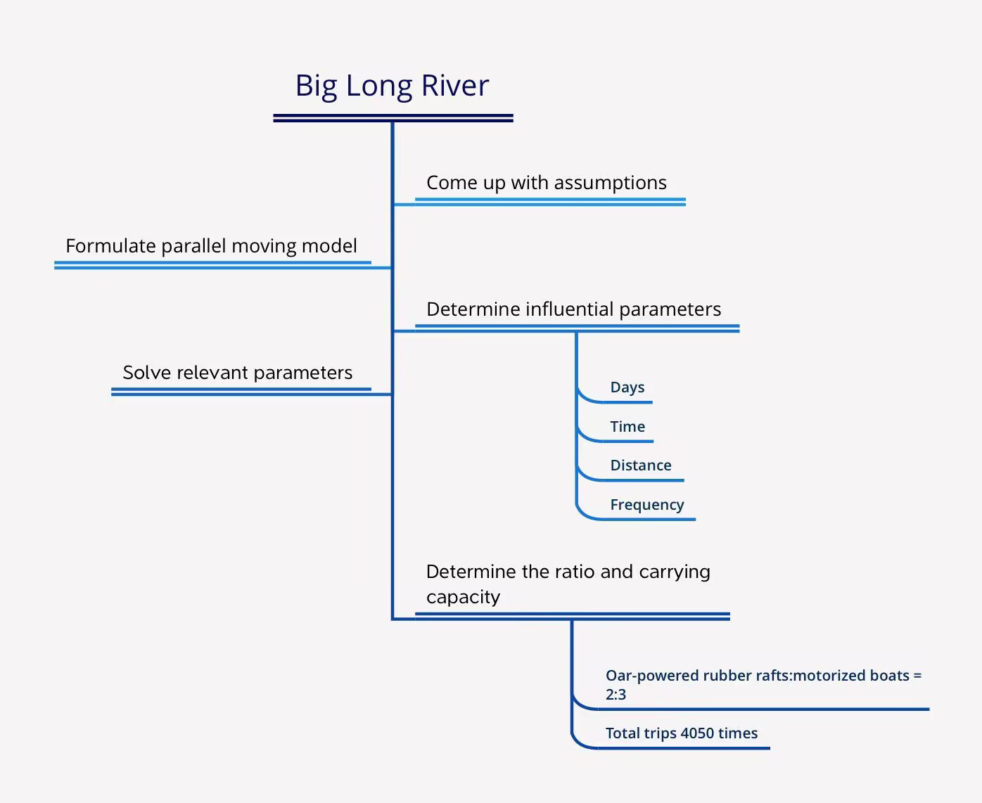

**Figure 1：Our work**

# Assumptions and Justifications

1. **We assume that daytime travel time of up to 8 hours except for the last day.**

In fact as evidenced by the data that follows, the travel time for its longest travel option mode is 8 hours.

1. **We assume that the travelers start traveling immediately at the end of the night.**

In order to ensure the safety of visitors and staff, it was decided not to travel at night and to leave again at 8 a.m.

1. **We assume that water velocity have no effect on the kayak's speed.**

Water velocity is constant and can be reflected in the sensitivity analysis that follows.So this assumption is reasonable.

1. **We assume that the same type of vessels depart each day and that the vessels sent on the same day run at the same speed and for the same running time.**

During the trial period of the camp, an equal distribution of oar- powered rubber rafts and motorized boats, each with a 50% share, was used, and the oar- powered rubber rafts and motorized boats was subsequently adjusted according to the needs and feedback of the visitors. This allows for an effective simplification of the model and is also realistic.

1. **We assume that ignore variables that may affect the maximum distance travelled per day, such as weather, river conditions, counterweight, etc.**

Factors such as weather and river conditions are uncontrollable variables and this has no way of being accurately included in the model.

# Notations

The key mathematical notations used in this paper are listed in Table 1.

Table 1: Notations used in this paper

|  |  |  |
| --- | --- | --- |
| **Symbol** | **Description** | **Unit** |
| Y | Total number of camps | \ |
| Kj | Number of nights in total for j-th trip | day |
| tij | i-th trip, j-th daylight walk time | hour |
| g | Maximum number of trips per day | \ |
| vj | Speed of travel mode chosen for the j-th trip | mph |
| D | Current day of the trimester | day |
| L | Distance between two adjacent campsites | km |
| q | Number of days in three months that someone travelled | day |
| t | Time interval between two adjacent trips in the same day | hour |
| hi | Number of people on tour on j-th day | \ |

# Model 1 : Parallel Moving Model

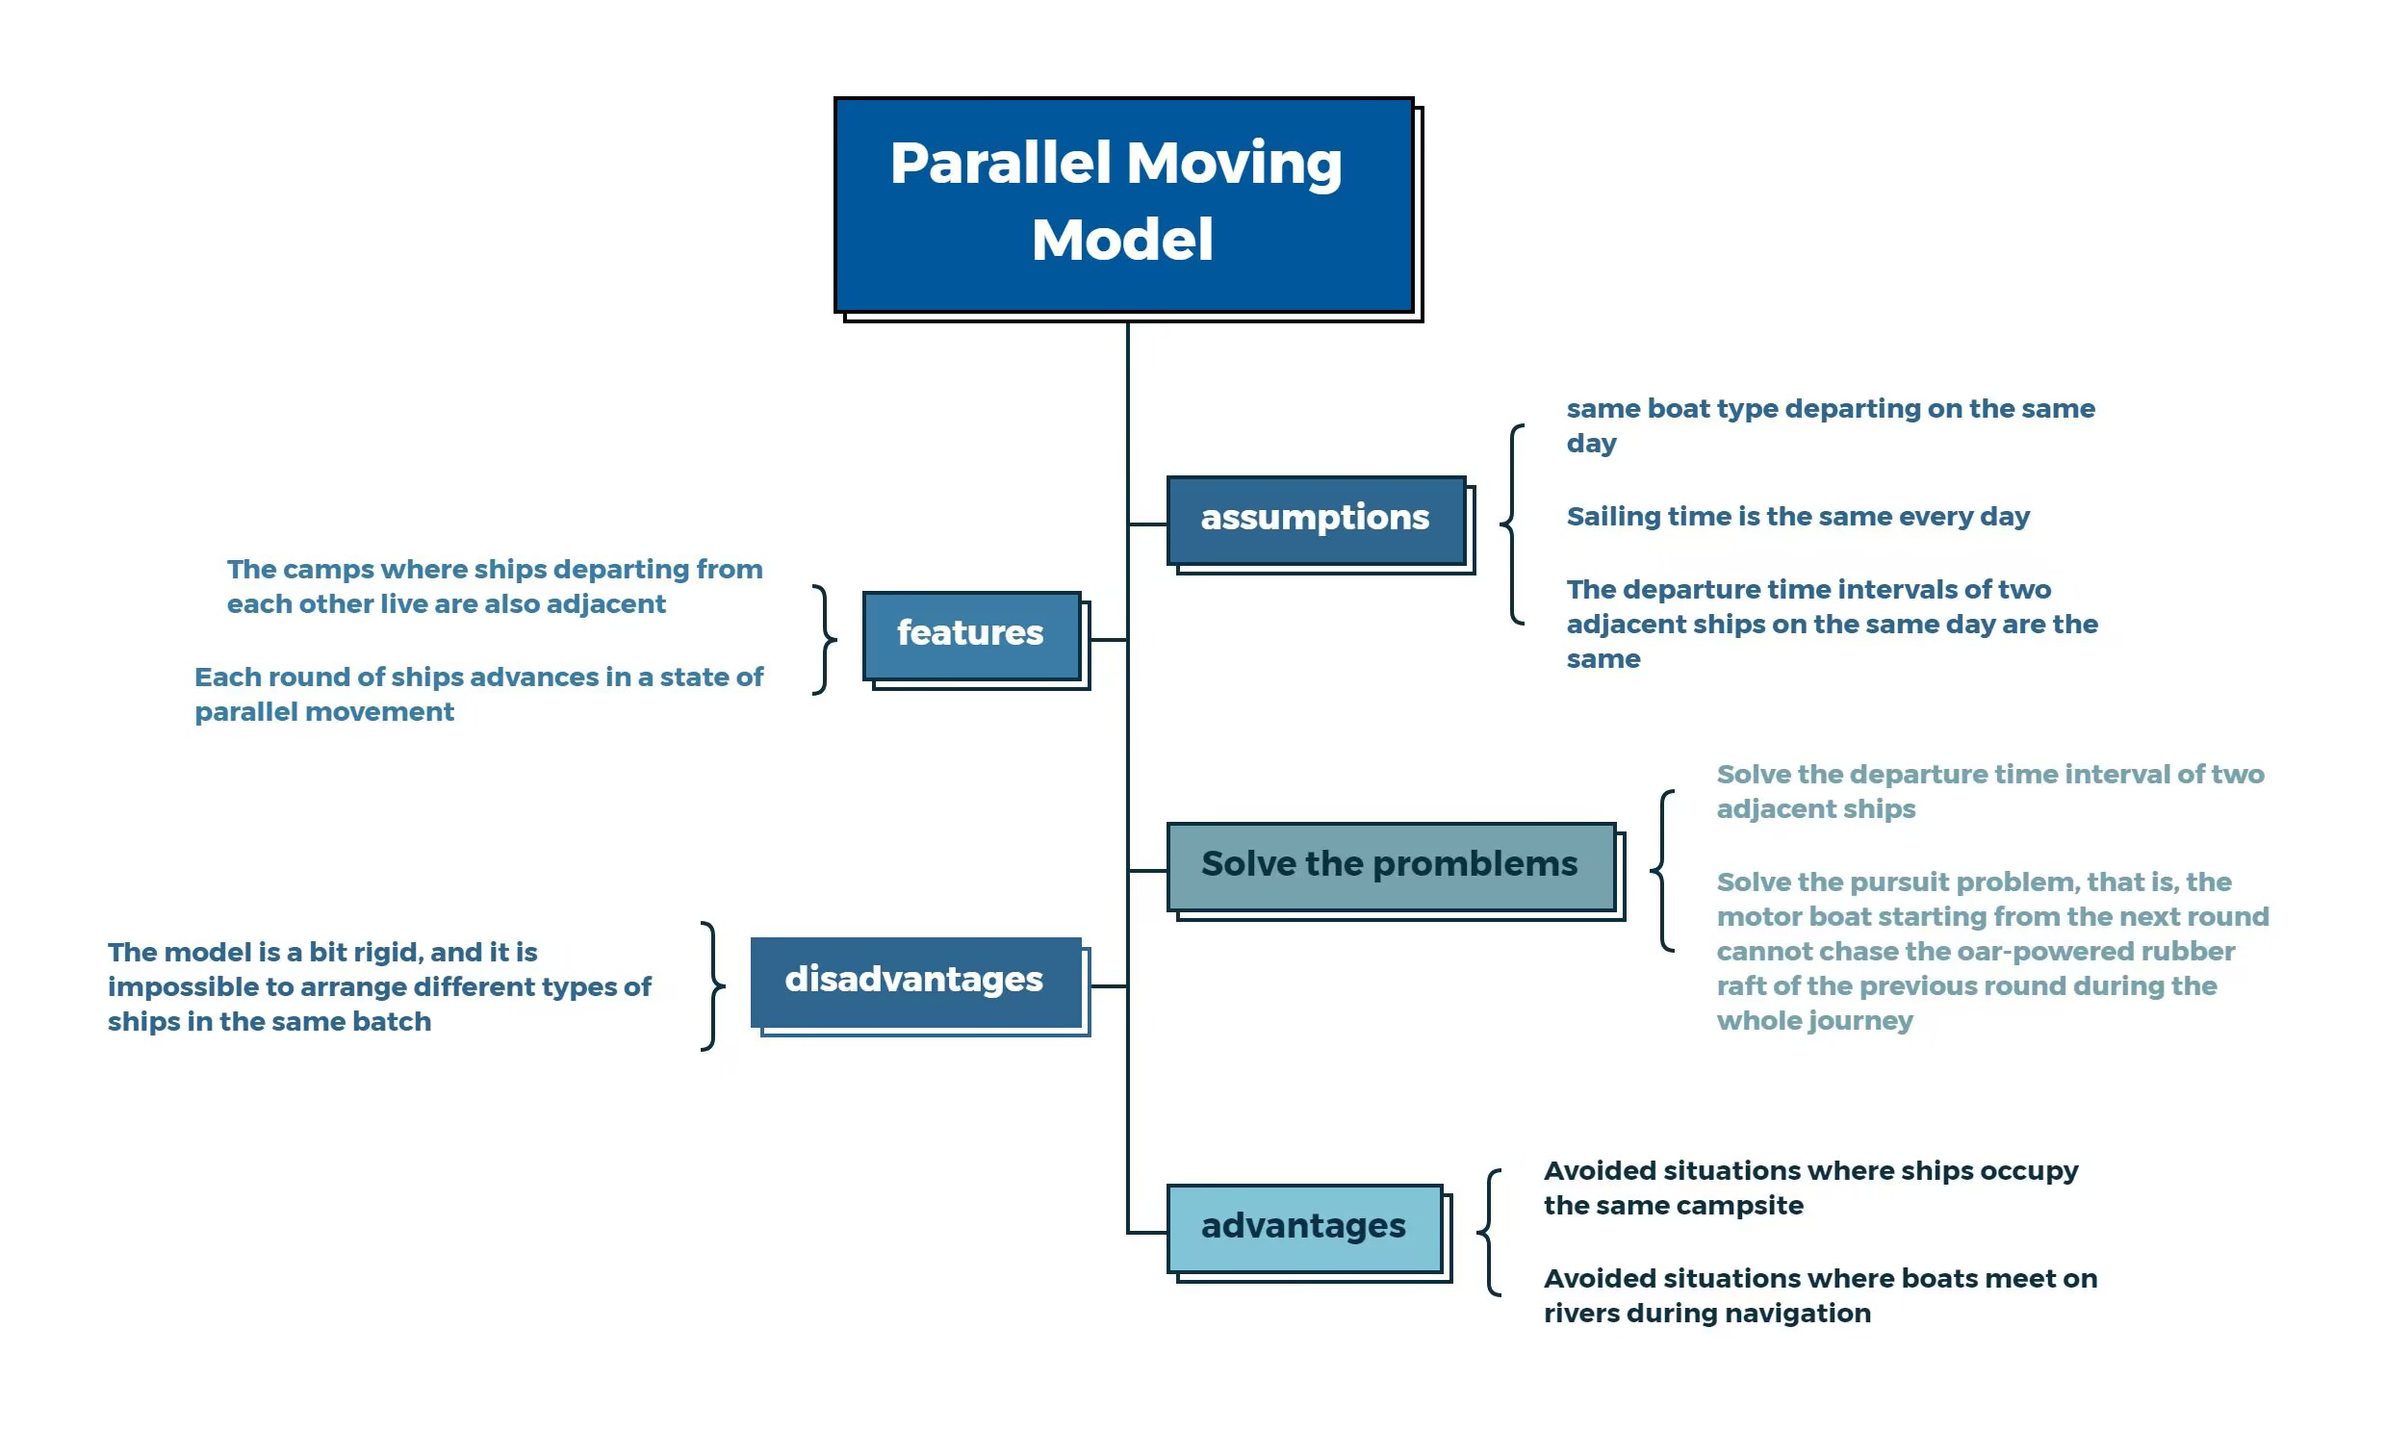

**Figure 2: Parallel movement model**

Obviously, the above diagram shows: the model assumptions of the parallel moving model, the model characteristics, the main problem solving of the model and the advantages and disadvantages of the model.

## The Establishment of Model 1

In the previous discussion, we have assumed that the same type of vessel departs each day and travels the same amount of time on each day except for the first and last day; the dispatch interval between two adjacent vessels is also the same. Therefore, we can obtain vessels departing within the same day whose chosen campsite is adjacent to each other on each night of their journey. In other words, the movement of the vessels is a parallel moving model [1], as shown in Figure 3.

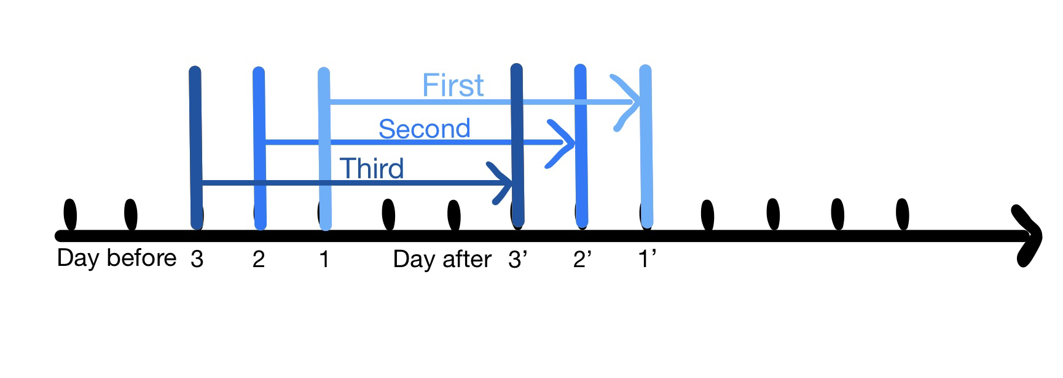

**Figure 3: Parallel moving model**

As can be seen from the diagram above: boats departing on the same day will not meet during the run, that is the objective of minimum contact with other boats is achieved, and teams departing on the same day will not meet at the same camp.

After analysis, it is concluded that not all boat trips are made every day, and if the trip needs to be within the range to choose the time, so it is need to satisfy

|  |  |
| --- | --- |
|  | () |

If there is a boat trip, then Kj is not zero, so

|  |  |
| --- | --- |
|  | () |

|  |  |
| --- | --- |
|  | () |

The campsites are evenly distributed along the river, then

|  |  |
| --- | --- |
|  | () |

In order to allow travel time for the last group to depart on the day, then the following needs to be met

|  |  |
| --- | --- |
|  | () |

Assuming that only 4 mph oar- powered rubber rafts are issued on one day and 8 mph motorized boats on the other, in order to ensure that there are not two groups at a campsite, we need to ensure that the earliest group on the motorized boat on the latter day cannot catch up with the latest group on the oar- powered rubber rafts on the previous day. That is

|  |  |
| --- | --- |
|  | () |

Among the above formula,  indicates the maximum number of days that the day after catches up with the day before，4 indicates maximum catch-up speed difference， indicates maximum daily catch-up time， indicates the distance covered on the first day by the group that started the latest on the previous day.

Set Hj means that as of day j, there are several days with people and no completed trips,in other

|  |  |
| --- | --- |
|  | () |
|  | () |

Only 4 mph oar- powered rubber rafts and 8 mph motorized boats are available, so the speed of the chosen mode of travel should meet

|  |  |
| --- | --- |
|  | () |

Besides，the number of days of travel should be a whole number，which means Kj is a whole number.

Taking the above factors into account, Model I was developed as follows.

Target function

|  |  |
| --- | --- |
|  | () |

Restrictive conditions

|  |  |
| --- | --- |
|  | () |

## The Solution of Model 1

Based on the above model, we have derived the objective function and the associated constraints. At this point, the objective function is solved by using the lingo[2] software to obtain the relationship between the percentage of motorized boats and the total number of vessels travelling, as shown in Figure 4.

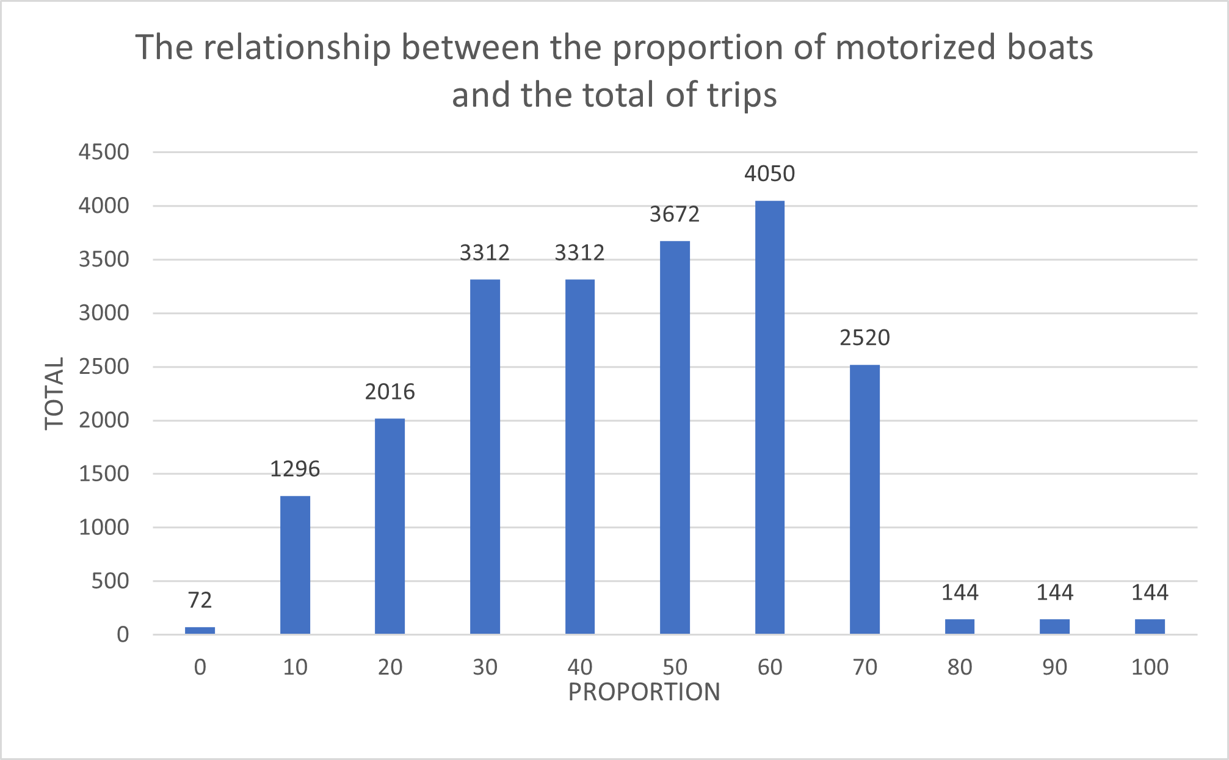

**Figure 4: The relationship between the proportion of motorized boats and the total of trips**

From the graph it can be concluded that the maximum number of boat trips is 4050 when the proportion of motorized boats is 60%. So arranging a ratios of 2:3 between oar- powered rubber rafts and motorized boats allows for the maximum number of trips to be made during the June tourist season.

# Model 2 : Generalized Model of Maximum Number of Trips

In addition to model 1 above, another model, Generalized Model of Maximum Number of Trips , has been developed to solve the problem. The model is presented in the figure below.

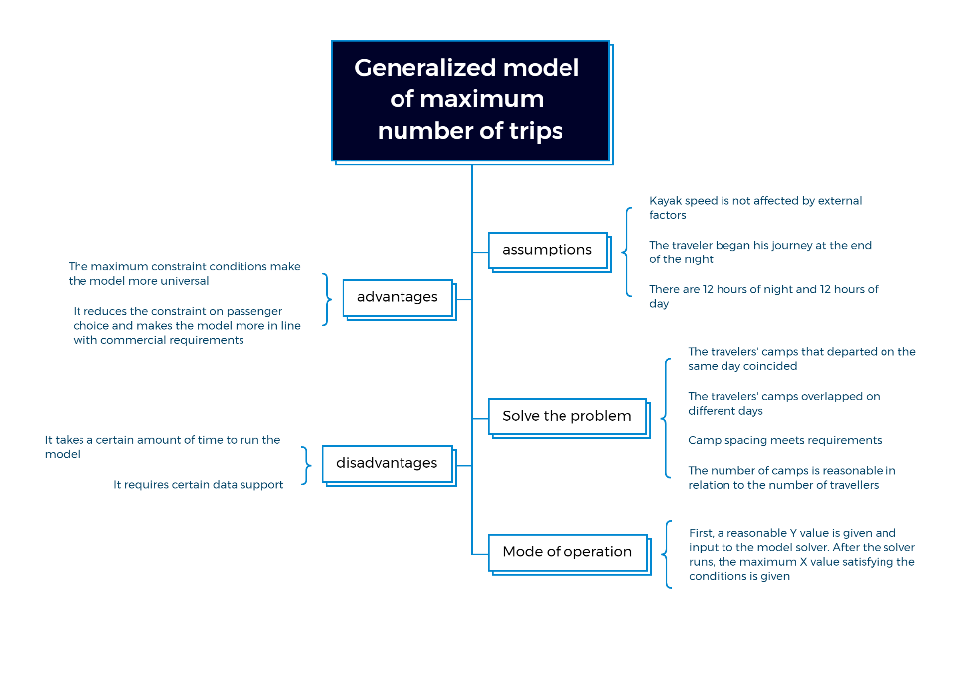

**Figure 5:Generalized model of maximum number of trips**

## The Establishment of Model 2

To get the maximum number of days we can travel, we assume it is X. So all we need to ask for is the maximum value of X, which is .

mi denotes the departure time of the i-th trip in three months，first trip from day 1,so

|  |  |
| --- | --- |
|  | () |

Less than 12 hours of daylight, that means

|  |  |
| --- | --- |
|  | () |

The final trip needs to be completed within a set time frame, for a total of 180 days of travel, then

|  |  |
| --- | --- |
|  | () |

No further trips can be made for the time remaining after the last trip has been completed, therefore

|  |  |
| --- | --- |
|  | () |

Since the trip is for 6 to 8 nights, Kj should satisfy

|  |  |
| --- | --- |
|  | () |

The k-th daytime of i-th trip hasn’t covered 225 km , so

|  |  |
| --- | --- |
|  | () |

225 km must have been covered in the ki+1st daytime of the i-th trip, then

|  |  |
| --- | --- |
|  | () |

The time of the last day walk can be expressed as

|  |  |
| --- | --- |
|  | () |

Only 4 mph oar- powered rubber rafts and 8 mph motorized boats are available, so the speed of the chosen mode of travel should meet

|  |  |
| --- | --- |
|  | () |

The campsites are evenly distributed along the river, then

|  |  |
| --- | --- |
|  | () |

Marching throughout the day and making sure to walk at least from the current campsite to the next one, so

|  |  |
| --- | --- |
|  | () |

Travel for a total of 3 months, then D and mi should satisfy

|  |  |
| --- | --- |
|  | () |
|  | () |

Fi denotes the number of daylight days already travelled on i-th trip. The number of daylight days that have been travelled is equal to the current date minus the departure date, then it should satisfy

|  |  |
| --- | --- |
|  | () |

If the date of departure of the i-th trip plus the number of days to be travelled is less than the current date, it means that the travellers are still in transit, which use set U to express as

|  |  |
| --- | --- |
|  | () |

If p and q belong to U, for teams p and q not to meet at the same campsite, in other they travel different distances when the night comes, they should satisfy

|  |  |
| --- | --- |
|  | () |

To Ensure the campsites enough, the number of people still travelling should be less than the number of campsites, so

|  |  |
| --- | --- |
|  | () |

There is one more day than night, then the number of days is Ki+1 and the number of days of daylight already travelled should satisfy

|  |  |
| --- | --- |
|  | () |

The length of travel on day j of the i-th trip must be an integer multiple of L, which means

|  |  |
| --- | --- |
|  | () |

and that n cannot exceed the ratio of the distance travelled at maximum speed in a day to L for the longest time, so

|  |  |
| --- | --- |
|  | () |

Guaranteed forward march, tij should meet

|  |  |
| --- | --- |
|  | () |

If the departure date is greater than the current date, it means that there is no departure now and is represented by the set A as

|  |  |
| --- | --- |
|  | () |

And 、.

In addition to the above constraints, mi, Ki, D, Fi, n are integers and D is self-increasing by 1.

Taking the above factors into account, Model 2 was developed as follows:

Targeted function

|  |  |
| --- | --- |
|  | () |

Restrictive conditions

|  |  |
| --- | --- |
|  | () |

## The Solution of Model 2

With more time and sufficient data, the model might have yielded a more optimal solution.

# Sensitivity Analysis (Model 1)

Sensitivity analysis is the calculation and analysis of the error introduced by the model, the effect of small changes in variables on the model results, etc [3]. In this paper, we perform a sensitivity analysis on model one. After discussion, we can know that the two factors that have the greatest influence on the optimal solution of model one are the speed order of the vessel and the speed magnitude of the vessel respectively. Therefore, we vary these two factors separately and ensure that other conditions remain unchanged to calculate the optimal solution and sensitivity under different situations.

## Effect of the ship's speed sequence on the optimal solution

We change the order of the boat's speed in turn, varying it by 0.01 each time, from 0 all the way to 0.15. and ensuring that all other conditions remain the same, and substitute into model one separately to obtain the corresponding optimal solution (as in Figure 6), and then calculate the respective sensitivity (as in Figure 7).

|  |  |
| --- | --- |
| Figure 6 | Figure 7 |

As can be seen from Figures 6 and 7, the optimal solution is still 4050 times, changing the order of the boat's speed, and the sensitivity does not exceed 1.3.

## Effect of the size of the ship's speed on the optimal solution

We vary the magnitude of the boat's speed in turn, by 0.01 each time, from -0.05 all the way up to 0.15, and ensure that all other conditions remain constant, and substitute into model one separately to obtain the corresponding optimal solution (as in Figure 8), and then calculate the respective sensitivity (as in Figure 9).

|  |  |
| --- | --- |
| Figure 8 | Figure 9 |

As can be seen from Figures 8 and 9, changing the speed magnitude of the boat, the optimal solution is still 4050 times and the sensitivity does not exceed 0.7.

In the figure above, we performed sensitivity analysis on the data. According to the data, the mean sensitivity is below 0.4. Although some data have high sensitivity, it is actually due to the fact that we use a random generation method when generating the daily distribution of ship types, which will inevitably produce poor data, but this does not affect the stability of our model, otherwise the model will not produce low sensitivity in the subsequent data. In the analysis of sensitivity of kayak speed, it is also due to the generation of some abnormal data, which leads to the excessively high sensitivity, but it is concentrated in the range with large speed change, which corresponds to the situation that external factors have a great influence on the speed of kayak. Considering the actual situation, in a certain period of time (three months), the climate change will not be great. As a result, there will not be a large change in speed, so we can appropriately discard abnormal data. So our model is stable.

# Model Evaluation and Further Discussion

## Strengths

1. Model 1 avoids the situation of vessels occupying the same camp and vessels meeting during the run, simplifying the problem and making the model more concise.
2. Model 2 does not assume as many conditions and is more generalisable and practical than Model 1.
3. Model 2, it reduces the constraint on passenger choice and makes the model more in line with commercial requirements

## Weaknesses

1. The solution to Model 2 needs to be derived from X, which requires data support.
2. Model 2 takes a lot of time to run through the program.
3. Both Models 1 and 2 ignore uncontrollable factors such as weather, which may have some influence on the results.

## Further Discussion (Model Extensions)

**Model 1**: Parallel model, in essence, is that members of the same group move at equal intervals, and the next group of members set off at a regular time, which makes it impossible to pursue. The model can also be applied to the travel arrangement of tour groups, especially to the design of highway green wave belt has certain reference significance.

**Model 2**: When the model is generalized, the speed can be extended to range rather than limited to some quantitative values. The model is more universal and can be applied to the berthing problem of ships and the berthing problem of highway, railway, aircraft and other transportation modes.

# Conclusion

We propose an effective way to solve the problem of the maximum number of trips in three months. The difficulty with this problem is that there cannot be two groups of travelers in the same camp on the same night. So we set up two models to solve it. The parallel movement model is a way to solve this problem in a finite time. We find that the optimal solution for the **maximum number of trips X is 4050 when the number of camps Y equals 500.**

Then we tested the sensitivity of the daily canoe speed arrangement and the canoe speed in the model. The test results show that our model is stable and feasible. However, considering that this model has strong constraints on the choice of tourists, we put forward model two: the universal model of the maximum number of Tours. This model reduces the constraint on tourists' choice to the greatest extent, which is undoubtedly in line with the commercial requirements and the needs of tourists. We believe that with sufficient time and sufficient data, the application of Model 2 will produce a more optimized result. Of course, our model is not only limited to this problem, but also has strong reference significance for traffic arrangement.

**Memo**

To whom it may concern,

We would like to inform you of the results that we found from our analysis into the problem of creating a schedule and determining the carrying capacity of the Big Long River.

Big Long River attracts more and more people to travel, so it is a deal to figure out how to develop better plans that balance ecological environment and life safety while providing better wilderness experiences for passengers has become a problem.

In addressing this issue, we propose two models for obtaining optimal time schedules while ensuring the river's carrying capacity. These two models can be used respectively in the classic trial run stage and the mature operation stage after obtaining enough data. We hope it will be helpful for your river management.

We named Model One "Parallel Moving Model" because it has the characteristic of parallel movement. Specifically, by specifying different batches of travelers to use different types of boats and travel time intervals, we can ensure that boats departing nearby will camp at nearby campsites, thus solving the problem of chasing boats departing on the same day, while maximizing the utilization of campsites. Additionally, we also address the problem of crashes between different batches of departing boats through calculation, and the specific details of the solution are explained in the article.

Model Two can be considered as the "flexible version" of Model One, as it does not have as many constraints as Model One. With sufficient data from our scenic area's trial operations, such as peak and off-peak seasons, preferred types of boats, and average daily travel time, we can use Model Two to more efficiently plan travel itineraries that cater to the specific needs and preferences of our visitors. This allows for a more personalized and enjoyable camping experience for our guests, while also maximizing the utilization of our resources.

In addition, through thorough data simulation and sensitivity analysis, we have confidently determined that "our model is steady and reliable". This conclusion is based on the model's ability to withstand various scenarios and changes in parameters, without losing its effectiveness. We have also verified that our model is able to provide stable and accurate results in different situations. We believe that the solutions we have proposed can effectively assist in managing and developing rivers while ensuring safety and providing a high-quality wilderness experience for visitors.

Thank you for reading this letter.

# References

[1] Hu,D.-C. Anatomy of a parallel sequential movement approach [J].

[2] Hong,W. Zhu,Y.-J. Jin,Z. Wang,Q.-W. Optimisation modeling with lingo[J]

[3] Yu,L.-P. Pan,Y.-T. Wu,Y.-S. Research on sensitivity analysis of science and technology evaluation - individual and combined indicators [J].

# Appendices

|  |
| --- |
| Appendix 1 |
| Introduce: Code to solve the model 1 |
| Model:  sets:  Day/1..180/:k,v,n;  endsets  data:  v=8.0 8.0 4.0 8.0 8.0 4.0 8.0 8.0 4.0 8.0 8.0 8.0 8.0 8.0 8.0 8.0 4.0 4.0 4.0 8.0 4.0 4.0 8.0 8.0 4.0 8.0 4.0 4.0 8.0 4.0 4.0 4.0 8.0 8.0 8.0 4.0 8.0 4.0 8.0 4.0 4.0 4.0 8.0 4.0 4.0 8.0 4.0 8.0 8.0 8.0 8.0 8.0 4.0 4.0 8.0 8.0 8.0 4.0 4.0 4.0 8.0 8.0 4.0 4.0 8.0 8.0 8.0 4.0 4.0 8.0 4.0 8.0 8.0 8.0 4.0 4.0 4.0 8.0 4.0 8.0 8.0 8.0 4.0 8.0 4.0 4.0 8.0 4.0 4.0 8.0 4.0 8.0 8.0 4.0 4.0 4.0 4.0 8.0 8.0 4.0 8.0 4.0 4.0 4.0 8.0 8.0 4.0 8.0 8.0 8.0 8.0 4.0 8.0 8.0 4.0 8.0 4.0 4.0 4.0 8.0 4.0 8.0 4.0 8.0 8.0 4.0 8.0 8.0 8.0 8.0 4.0 8.0 4.0 4.0 4.0 8.0 8.0 8.0 8.0 4.0 8.0 4.0 4.0 8.0 4.0 8.0 4.0 8.0 4.0 8.0 8.0 4.0 8.0 8.0 8.0 8.0 8.0 8.0 4.0 8.0 4.0 4.0 4.0 8.0 4.0 8.0 8.0 4.0 8.0 4.0 8.0 8.0 4.0 8.0 8.0 8.0 4.0 8.0 8.0 8.0 ;  enddata  max=g*q;  Y=500;  q=@sum(Day(j):@if(k(j)-0.0001#gt#0,1,0));  @for(Day(j):k(j)>6*n(j));  @for(Day(j):k(j)<18*n(j));  (g-1)*t<8;  L=225/(Y+1);  @for(Day(j)|j#LE#179:4*225/(v(j)*(k(j)+1))*@if((k(j)-1)#le#k(j+1),k(j)-1,k(j+1))<v(j)*(8-(g-1)*t));  @for(Day(j):225*(k(j)-1)/(k(j)+1)+v(j)*(225*2/((k(j)+1)*v(j)))=225);  @gin(g);  @for(Day(j):@gin(k(j)));  @for(Day(j):k(j)>0);  @for(Day(j):@bin(n(j)));  t>0.1;  t<1;  end |